Setting up an rsyslog Server for Azure Sentinel
It's likely that many of the log sources you want to pull into Azure Sentinel only support syslog.
In this case you'll need the following components:
- A linux server.
- The Azure Log Analytics Agent - also known as the OMS agent (Operations Management Suite - the old name for what is the Azure Monitor or Azure Log Analytics Agent
And you'll need the following special configurations:
- Rsyslog configuration - rsyslog will collect your syslog events and dump them to a log file on your local disk.
- Optional: Azure Log Analytics > Advanced Settings > Data > Custom Logs - this is where you'll point to the log file containing your syslog data that was collected by syslog-ng.
  - This custom log configuration will be pushed down to the OMS agent, and the agent will track any changes to the log file created by rsyslog.
Once the above configuration is complete, the syslog events will show up in the Azure Log Analytics workspace, where you can:
- perform additional parsing
- query for specific security related events
- use all of the features in Sentinel for detecting threats, etc.
Note: additional parsing of the logs is out of the scope of this document, but instructions on 'parsing raw data' is provided in the link shown below.
Note: this article assumes you know some linux and how to navigate the Azure Log Analytics configuration UI in the Azure portal.

Step-by-step guide
Installing and Configuring the rsyslog server
- Make sure the date/time are accurate on your server or the installation will fail.
  - date -s "2 OCT 2006 18:00:00"
  - timedatectl set-timezone 'America/Chicago'
- for Ubuntu Linux:
  - Check that you’re using a version of supported linux with Python 3.x (2.x will fail)
  - apt-get update
  - apt-get install python 3.8
- For RedHat Linux:
  - yum install python3
  - ln -s /usr/bin/python3 /usr/sbin/python
  - yum install gdb
- Disable selinux - /etc/selinux/config
- Disable the local firewall (systemctl stop firewalld)
- Download any linux distro, power it up, and login as root.
  - I'm referencing Ubuntu since it seems to have the least number of dependencies that I needed to add.
  - https://ubuntu.com/download/server/thank-you?version=20.04&architecture=amd64
  - Rsyslog should already be installed as part of the distro.
- Test your configuration using netcat:
  - echo "Apr 29 06:31:42 172.17.0.1 netcat:Host bobby test log source:9.9.9.9 target:20.1.1.2 port:5555"| nc -v -u -w 0 localhost 514
  - Your log should show up in /var/log/messages
  - You may need to wait up to 5 minutes before performing the next step. This is because the OMS may need time to pull down it's configuration and then forward the log up to the Analytics Workspace.
- Logger test:
  - logger -p user.debug testing12345
  - note: logger may not work with -n <ip> but it should generate local traffic.
  - If you need tips about reading the ‘facility’ with tcpdump read this.
Installing and Configuring the Azure Log Analytics Agent (OMS) for Linux
- Login to the Azure portal and go to your Log Analytics Workspace.
- Navigate to: Agents mangement > Linux Servers
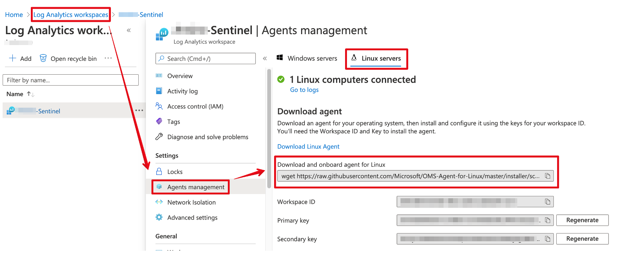
- Copy the 'wget' string under "Download and onboard agent for Linux"
- Paste this string into your syslog server and let it install the OMS agent.
  - Note: if you get a ‘--no-check-certificate’ error, add that option into the installation script – there are 2 lines that will need it.
- Test that the OMS agent is healthy:
  - On the Syslog-NG server, run this command:
    - /opt/microsoft/omsagent/bin/omsadmin.sh -l
    - The output should show something like this:
    - Primary Workspace: <workspaceId> Status: Onboarded (OMSAgent Running)
  - Go back to Log Analytics > Agent Management.
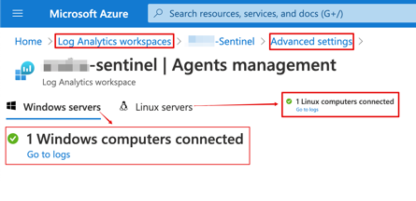
If you click on the 'go to logs' link (for Linux, not windows), a query will execute and show you the latest events received.
- Now configure syslog to receive all syslog ‘facilities’. This will ensure that all received syslog events will be forwarded up to your log analytics workspace.
https://docs.microsoft.com/en-us/azure/sentinel/connect-syslog
NOTE: BE PATIENT!!!!! It can take up to 10 minutes for the OMS agent to ‘call home’ and pull down it’s configuration from Azure. The configuration will show up in /etc/rsyslog.d/*.conf.
- Install CEF
  - Open Sentinel > Data Connectors > Checkpoint > Open Connector Page
  - Find the link that says ‘…apply the CEF collector’ and run this command on your syslog server.
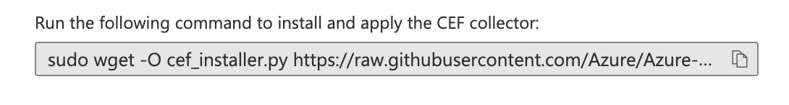

Checking for Data in Log Analytics
Azure Monitor Agent Heartbeat

Heartbeat
| where OSType == 'Linux'
| summarize arg_max(TimeGenerated, *) by SourceComputerId
| sort by Computer
| render table

Syslog Events from servers

Syslog
| where TimeGenerated > ago(24h)
| limit 10

Troubleshooting Tips
The 2 most interesting processes are omsconfig and omsagent:
omsconfig - checks back with Azure every 5 minutes to see if there's a need to update omsagent.conf.
omsagent - pulls all of the logs from linux and forwards them to Azure Log Analytics.
There should be no need to modify any of the files below manually, as the changes will be overwritten on the next push performed by osmconfig.
main start/stop script | sudo /opt/microsoft/omsagent/bin/service_control restart
change log_level from 'info' to 'debug' | /etc/opt/microsoft/omsagent/<workspace ID>/conf/omsagent.conf
or use this location, it's a sym link: | /etc/opt/microsoft/omsagent/conf/omsagent.conf
main omsagent log file (sym link) | /var/opt/microsoft/omsagent/log/omsagent.log
omsconfig log file | /var/opt/microsoft/omsconfig/omsconfig.log
When new custom logs are collected from a flat file, you'll see these messages in omsagent.conf  These messages are written to the log every 1 minute, regardless or not that a new log is seen. | 2020-04-30 12:54:51 +0000 [info]: INFO Following tail of /var/log/bobby.log
"" | 2020-04-30 12:54:51 +0000 fluent.info: {"message":"INFO Following tail of /var/log/bobby.log\n"}
"" | 2020-04-30 12:54:51 +0000 [debug]: Success sending 145 bytes of data to BLOB 0.738s
'custom logs' (flatfile log tailing) configuration file used by omsagent. | /etc/opt/microsoft/omsagent/<workspace ID>/conf/omsagent.d/customlog.conf
force omsconfig to pull a new configuration from Azure Monitor | sudo su omsagent -c 'python /opt/microsoft/omsconfig/Scripts/PerformRequiredConfigurationChecks.py'
check that omsconfig can talk to Azure Monitor and show current configuration. | sudo su omsagent -c 'python /opt/microsoft/omsconfig/Scripts/GetDscConfiguration.py'

Installing the OMS Agent:
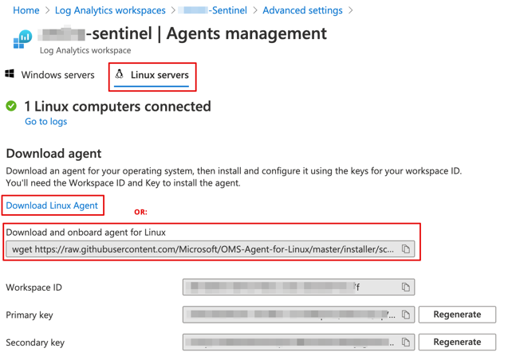

Optional Flatfile Configuration:
Configuring the OMS Agent to pull logs from /var/log/bobby.log:
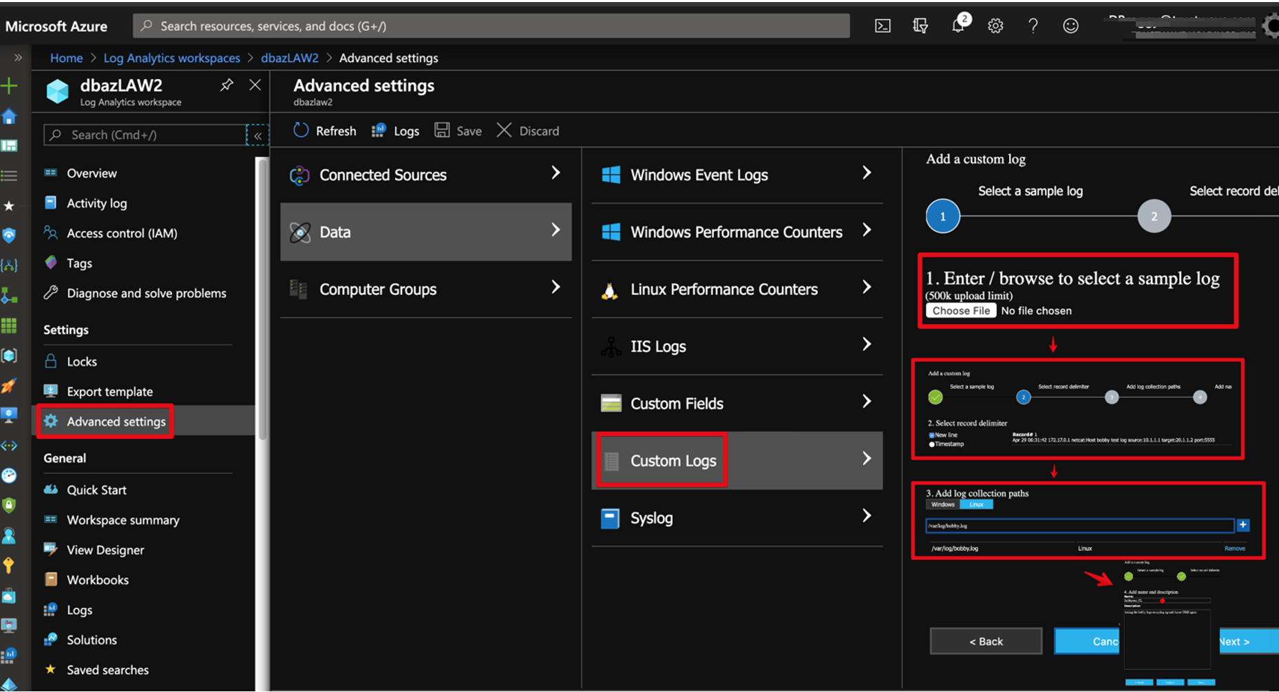
Querying all logs containing 'bobby':
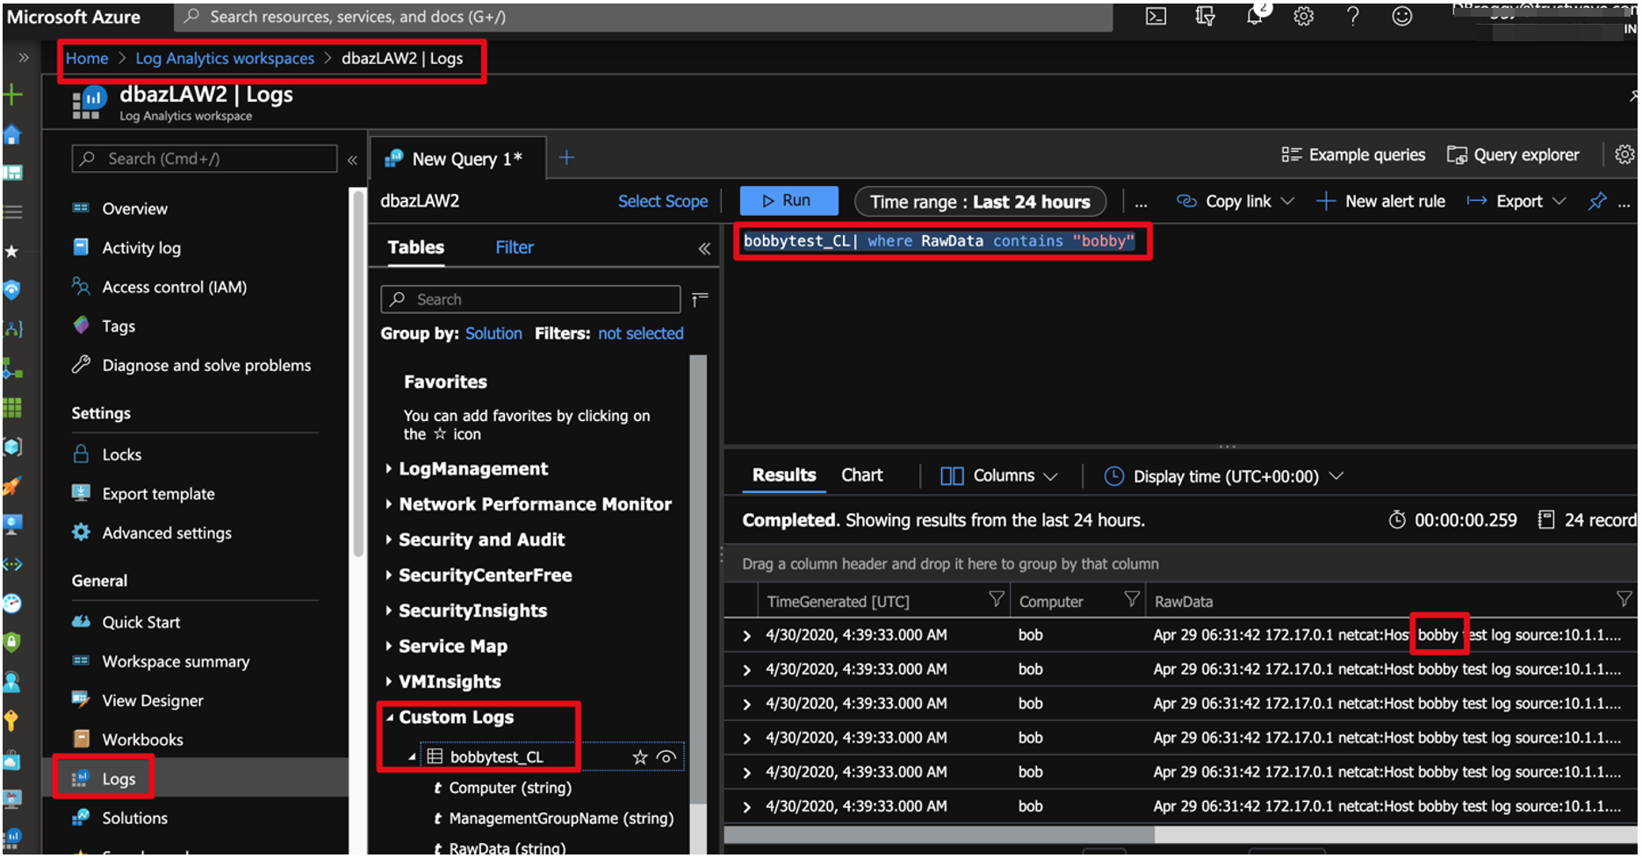

Related articles
Adding custom logs to Azure Monitor/Log Analytics | https://docs.microsoft.com/en-us/azure/azure-monitor/platform/data-sources-custom-logs
OMS Agent troubleshooting | https://docs.microsoft.com/en-us/azure/azure-monitor/platform/agent-linux-troubleshoot
Parsing raw data in Azure Monitor/Log Analytics | https://docs.microsoft.com/en-us/azure/azure-monitor/log-query/parse-text
Microsoft OMS Agent | https://github.com/Microsoft/OMS-Agent-for-Linux/wiki
Uninstalling the agent:
/opt/Microsoft/
- Wipe and re-install oms agent: purge_omsagent.sh
If this is an azure linux VM with the oms agent, disable it before installing:
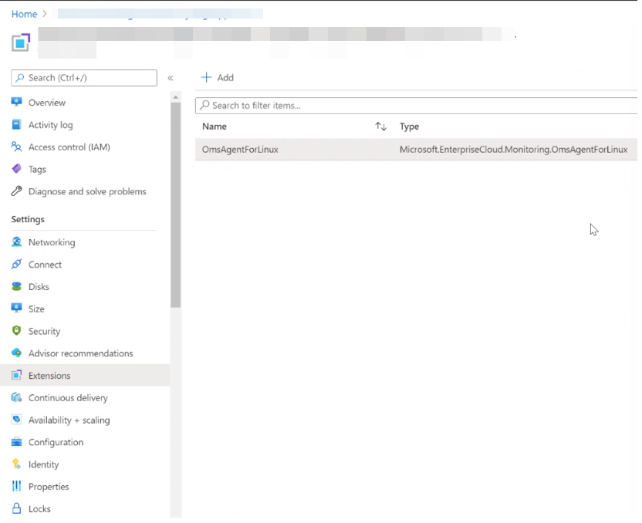
Disable firewall and selinux
systemctl start firewalld
./uninstall
reinstall
Purge
reinstall
Selinux
Stop firewalld
Verify syslog is listening: netstat -al|grep 514|grep LISTEN
Fixed listener

Working with Rsyslog 8.x

The “ModLoad” function from earlier versions of rsyslog has been deprecated.

Some tips on converting rsyslog.conf from old to new are here:
RSyslog Documentation - rsyslog
Raspberry Pi Syslog Server Setup - The Geek Pub

Add the following lines with purple text and comment out the deprecated ModLoad commands:

(then run systemctl restart rsyslog)

Some test/verification steps once rsyslog is changed:
(assumes checkpoint CEF logs)

CEF parsing is done by this file:
cat /etc/opt/microsoft/omsagent/<workspace> /conf/omsagent.d/security_events.conf

Which depends on this rsyslog config file:
/etc/rsyslog.d/security-config-omsagent.conf

That file forwards CEF logs locally to port 25226.

Tcpdump shows rsyslog forwarding the CEF logs to port 25226:

tcpdump -i lo port 25226

Finally, we can see the agent is getting the logs into Sentinel with with this query:

CommonSecurityLog​
| where DeviceVendor == "Check Point"
|order by TimeGenerated desc

Example Troubleshooting – Restarting the OMS Agent
Check that the OMS agnet is listening:
netstat -tulpn|grep 25226

Restarting the OMS agent:
/opt/microsoft/omsagent/bin/service_control restart

Checked again with netstat and you’ll see the PID has changed, which means the restart successfully killed the old process and restarted.

Verified OMSAgent was running:

/opt/microsoft/omsagent/bin/omsadmin.sh -l
Primary Workspace: [workspaceID] Status: Onboarded(OMSAgent Running)

Tail the OMSAgent log – you will see updates here every minute at least:
tail -f /var/opt/microsoft/omsagent/[workspaceID]/log/omsagent.log

Query CommonSecurityLog over the last 4 hours:

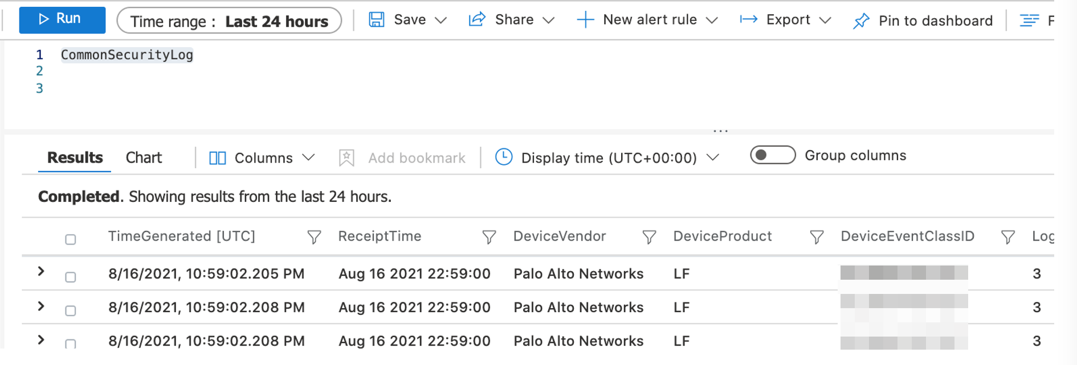
Full re-install and troubleshooting with CEF example
Original error:

/opt/microsoft/omsagent/bin/omsadmin.sh -l
ERROR: restart_omsagent failed with result '1' on workspace [workspaceID]

Purging the oms agent:

cd /opt/microsoft/omsagent/bin
chmod 744 purge_omsagent.sh
./purge_omsagent.sh
cd /opt/
wget https://raw.githubusercontent.com/Microsoft/OMS-Agent-for-Linux/master/installer/scripts/onboard_agent.sh
sh onboard_agent.sh -w [workspaceID] -s [secret] -d opinsights.azure.com

Restarting the agent (you don’t need to do this, just testing)
/opt/microsoft/omsagent/bin/service_control restart

Validating the connection:
root@vmSentinelSyslog:/opt# /opt/microsoft/omsagent/bin/omsadmin.sh -l
Primary Workspace: [workspaceID] Status: Onboarded(OMSAgent Running)

Validating /etc/rsyslog.d/95-omsagent.conf
Looking in this file you can see all syslog traffic is being forwarded locally to tcp 25224
So tcpdump can validate this:
tcpdump -i lo port 25224 -A -s0 -nn

Validating CEF processing
Download this script and run it:
sudo wget -O cef_troubleshoot.py https://raw.githubusercontent.com/Azure/Azure-Sentinel/master/DataConnectors/CEF/cef_troubleshoot.py&&sudo python cef_troubleshoot.py [WorkspaceID]
This showed me that this file was missing:
/etc/opt/microsoft/omsagent/[WorkspaceID]/conf/omsagent.d/security_events.conf
So I downloaded a new copy from the troubleshooting link shown below.
Then running the same command again fixed the CEF processing:
sudo python cef_troubleshoot.py [WorkspaceID]
Now I can see from tcpdump that the CEF logs (Checkpoint) are going to port 25226:
tcpdump -i lo port 25226 -A -s0 -nn

Troubleshooting reference:
https://docs.microsoft.com/en-us/azure/sentinel/troubleshooting-cef-syslog?tabs=rsyslog

